**ECE523 Final Project Report**

Bian Li

Jing Guang Sia

**Overview**

A differential amplifier, with a list of specifications, is designed. Results are simulated using HSPICE, and plotted with CosmosScope. Simulations are done under three temperature cases (270, -400and 1000), in which the power supply and capacitance undergoes variation. A folded telescopic cascode architecture is chosen for this project. Simulations showed that we met most, but not all, of the specifications.

**Specifications**

|  |  |
| --- | --- |
| Power Supply | 2.5V, 2.25V, 2.75V (typical, slow, fast) |
| Load at each output | 3pF, 3.9pF, 2.1pF (typical, slow, fast) |
| Loop Gain | >65dB |
| Loop UGBW | >100MHz |
| Loop Phase Margin | >600 |
| CMFB Phase Margin | >600 |
| CM Accuracy | <0.05B |
| Output Swing | >2V peak to peak |
| Power Consumption | <12mW |

**Architecture Rationale**

The folded telescope cascode has a high gain, due to its high output impedance. The telescopic cascode also has a high common mode feedback range. Setting the common mode voltage is also easy with the folded cascode. The architecture has only one stage, and does not suffer from phase margin as much as two stage opamps. Lack of any compensation capacitors also reduces the amount of space needed for the layout.

**Schematic**

Refer to the next page.

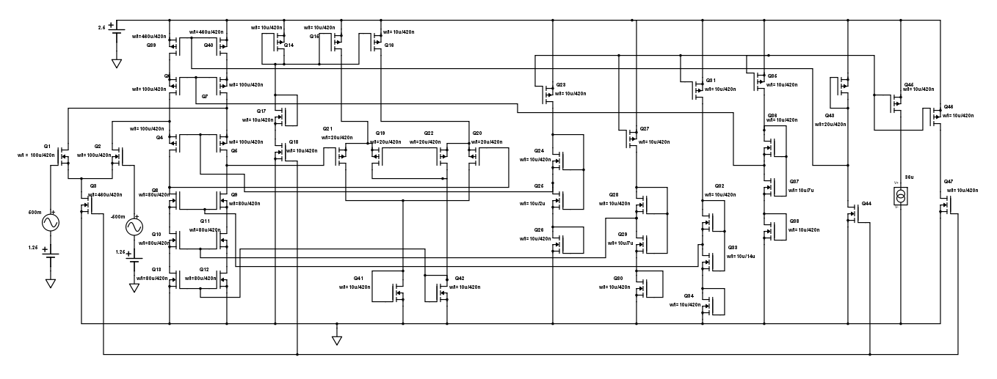

**Schematic Explanation**

The folded cascode is at the left part of the schematic, operating under a common mode input of 1.25V and a differential input of 500mV. Input stage aspect ratio is made as large as possible, to obtain a high transconductance, giving a high gain and bandwidth. The middle part of the schematic is the CMFB portion, with the feedback going back to the bottom part of the telescopic cascode. The right side of the circuit is for biasing the gates of the telescopic cascodes.

**Test-Benches**

Three different test-benches are used to test the differential, CMFB and output swing parameters. Refer to Appendix Part A for test-benches. The opamp is converted into a symbol, and it is used by all the test-benches.

**Results**

All evidences can be referred to in Appendix Part B. All graphs are drawn using CosmosScope, with data from HSpice simulations.

|  |  |  |  |
| --- | --- | --- | --- |
| Data | 270C | -400C | 1000C |
| Power Supply | 2.5 | 2.75 | 2.25 |
| Load at Each Output | 3p | 2.1p | 3.9p |
| Loop Gain | 80.719 | 67.614 | 87.508 |
| Loop UGBW | 192.9M | 323.35M | 101.66M |
| Loop Phase Margin | 59.370 | 58.010 | 63.20 |
| CMFB Phase Margin | 33.840 | 32.830 | 37.730 |
| CM Accuracy | 1.2003V | 1.1058V | 1.278V |
| Output Swing (Differential) | 0.875V | 0.343V | 0.588V |
| Output Swing (Single Ended) | 0.2475V | 0.394V | 0.321V |
| Power Consumption | 11.00029mW | 14.5361mW | 8.5348mW |

**Analysis**

Output swing is below requirements, as telescopic cascode transistors requires overdrive voltage to saturate them, lowering the available output swing range. The common mode phase margin is below the requirement. The huge aspect ratio introduces parasitic capacitors at the feedback stage, hence drastically lowering the common mode phase margin. At the fast case, the power supply becomes greater due to variation, and increases the power consumption.

**Layout**

Refer to Appendix Part 3 for layout screenshot, and DRC and LVS evidence.

Butterworth Filter

**Appendix**

A.1 Differential Test-Bench

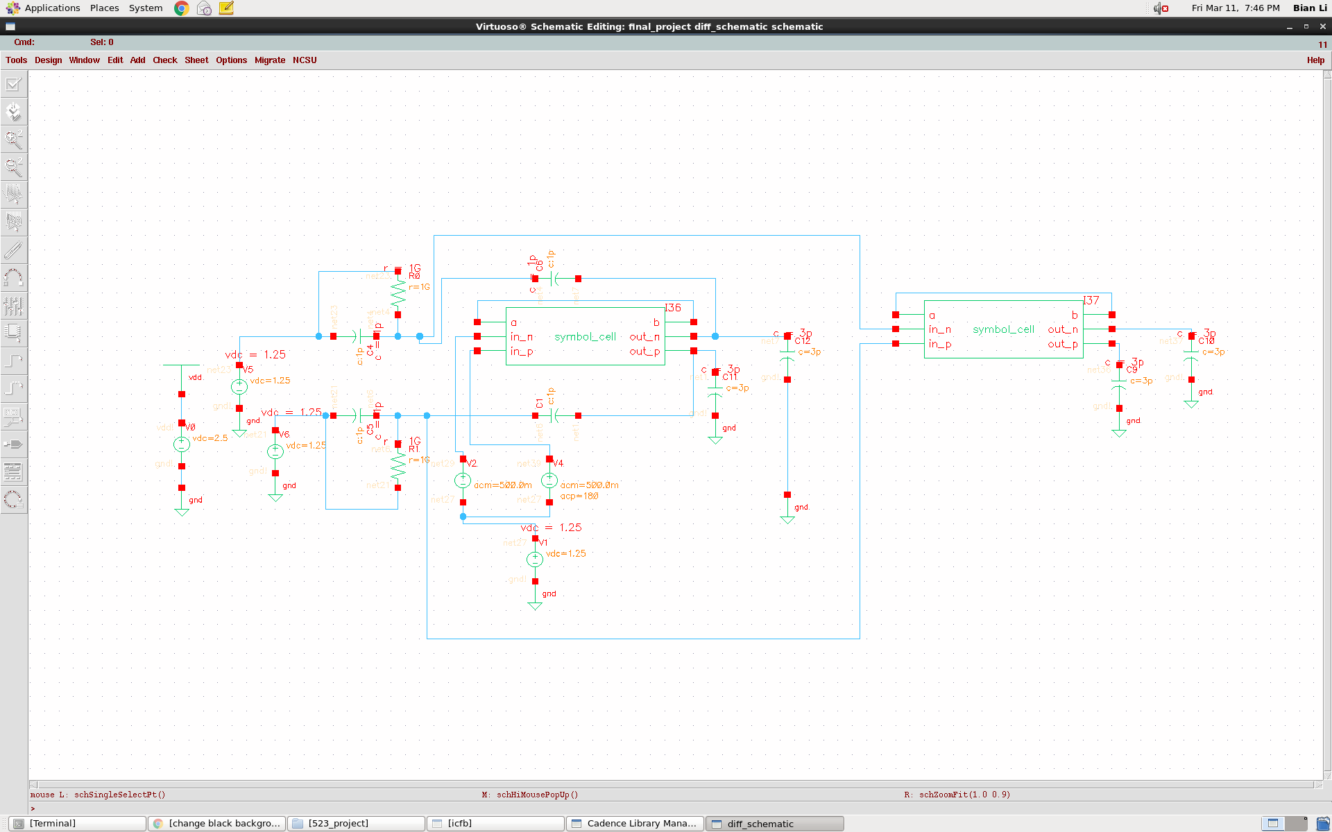

A.2 CMFB Test-Bench

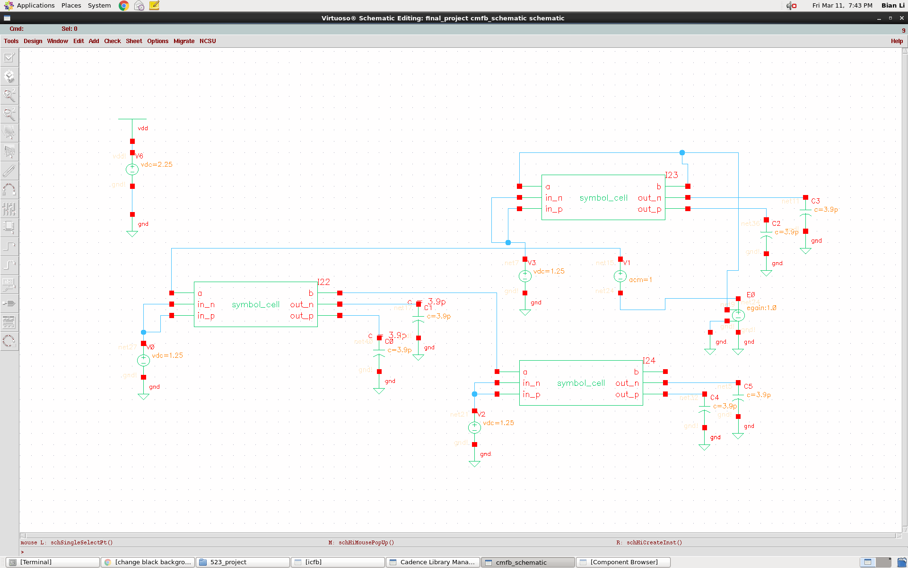

A.3 Output Swing Test-Bench

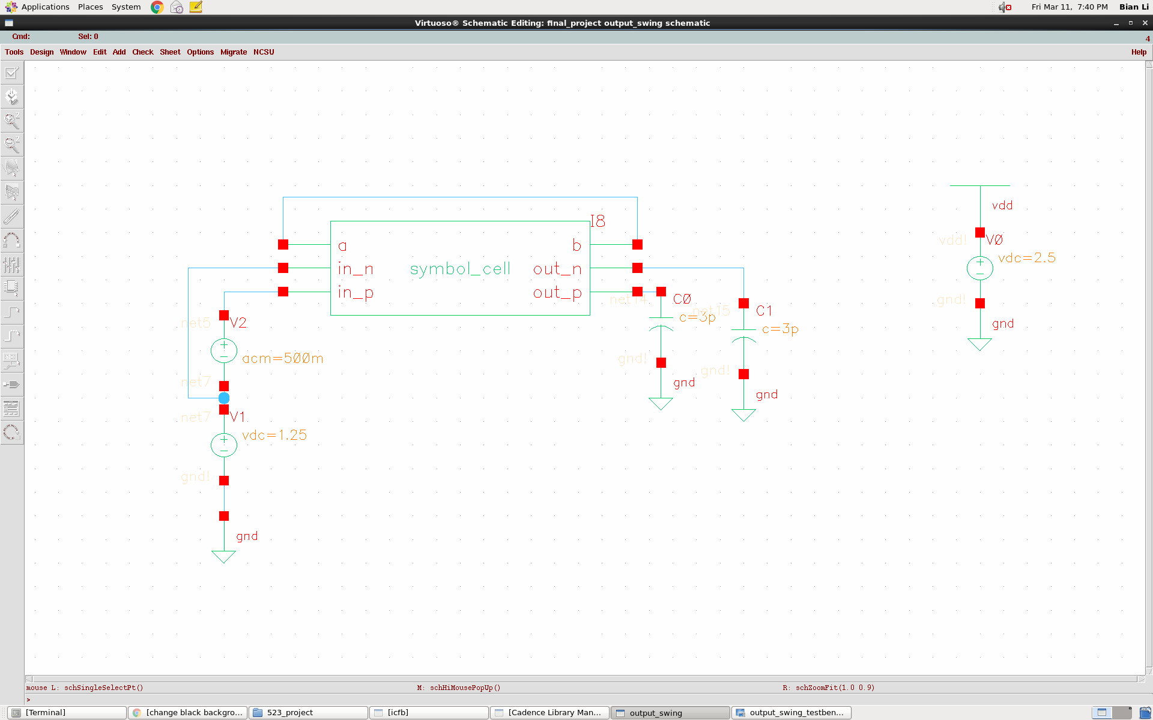

B.1 Typical case differential gain, UGBW and phase margin

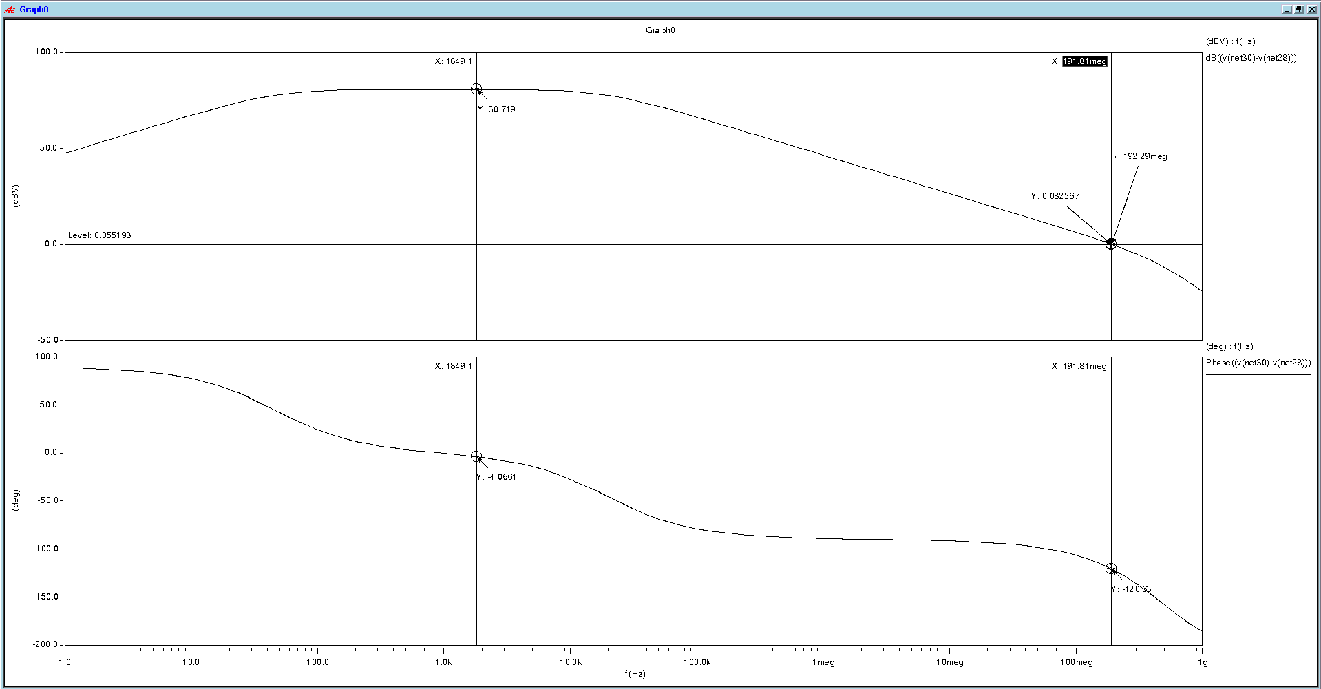

Typical case single-ended gain, UGBW and phase margin

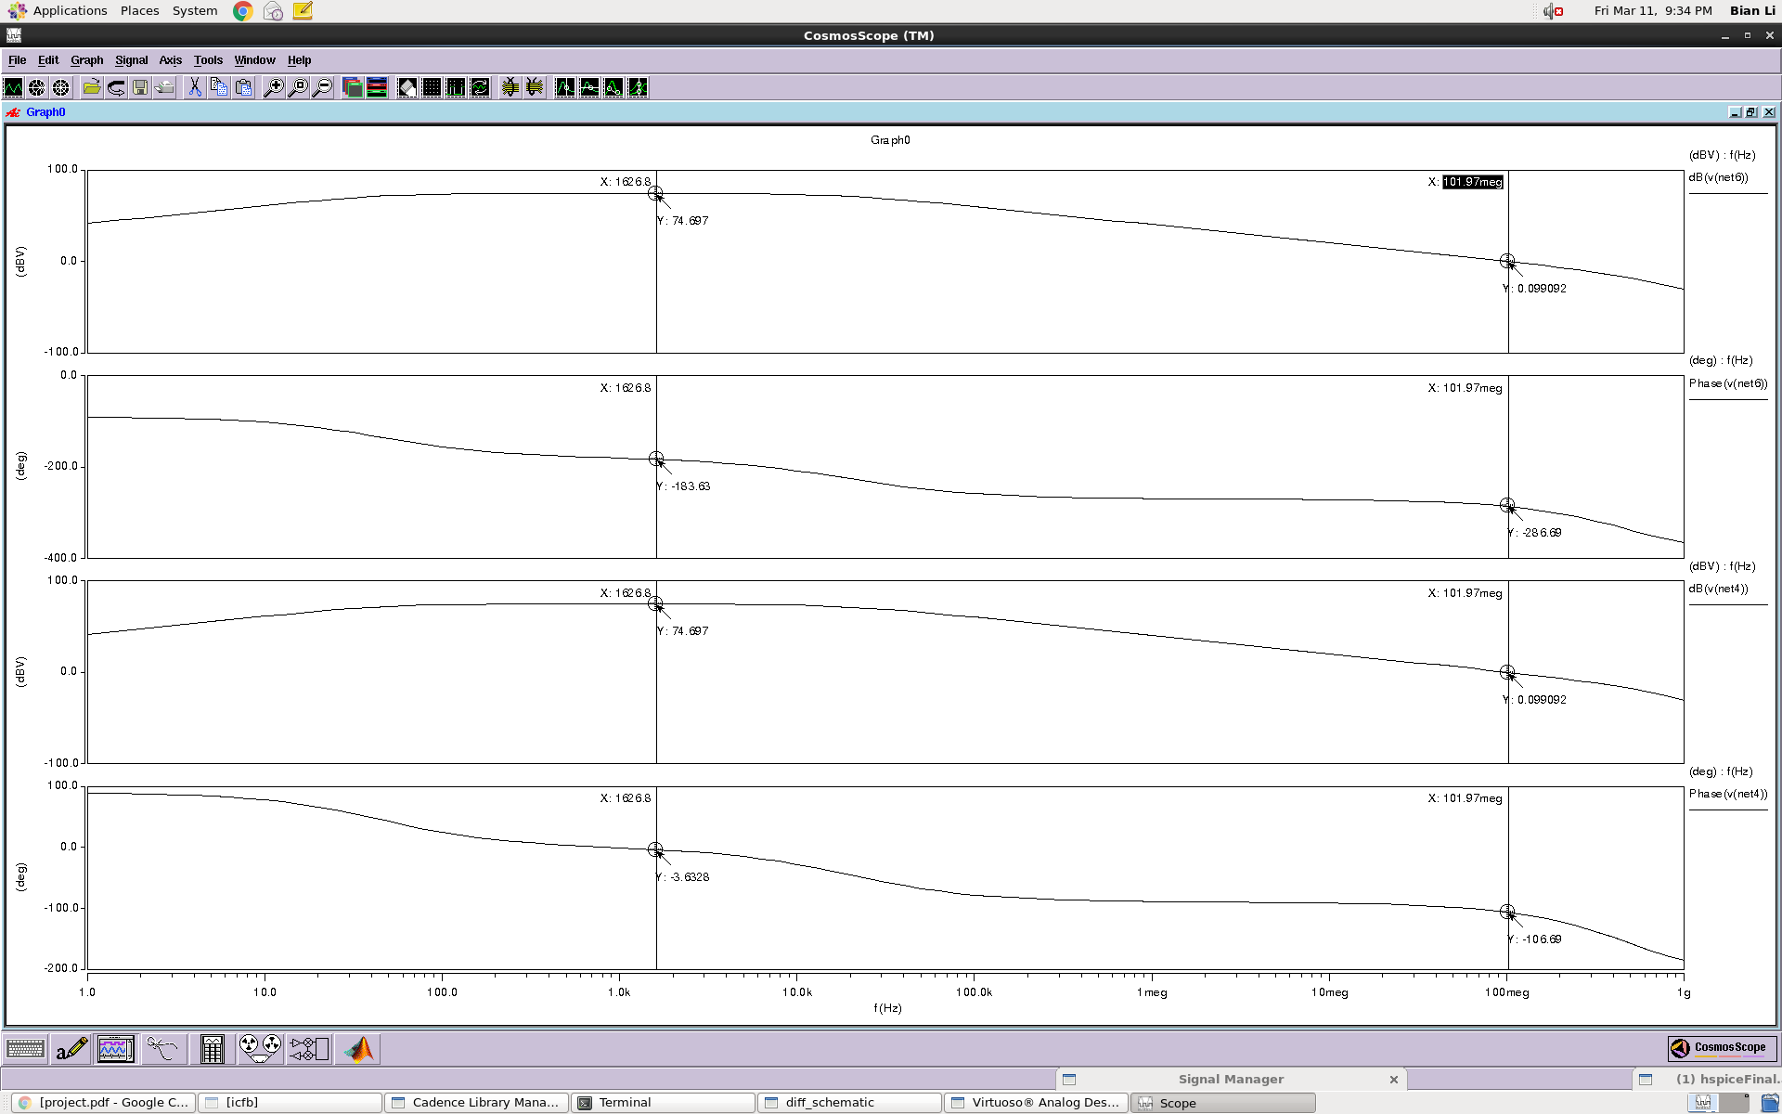

B.2 Slow case differential gain, UGBW and phase margin

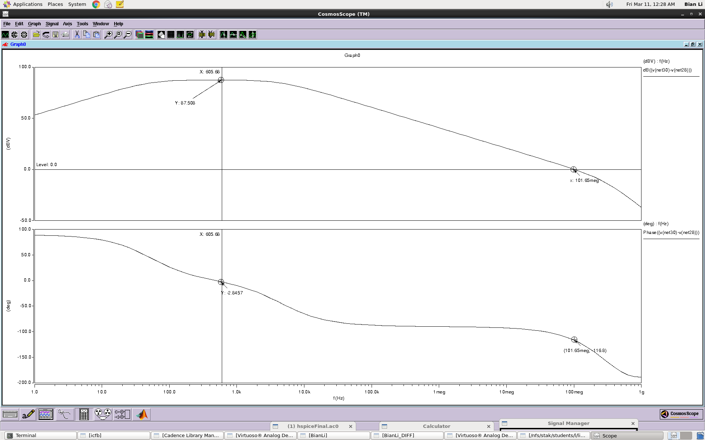

Slow case single ended gain, UGBW and phase margin

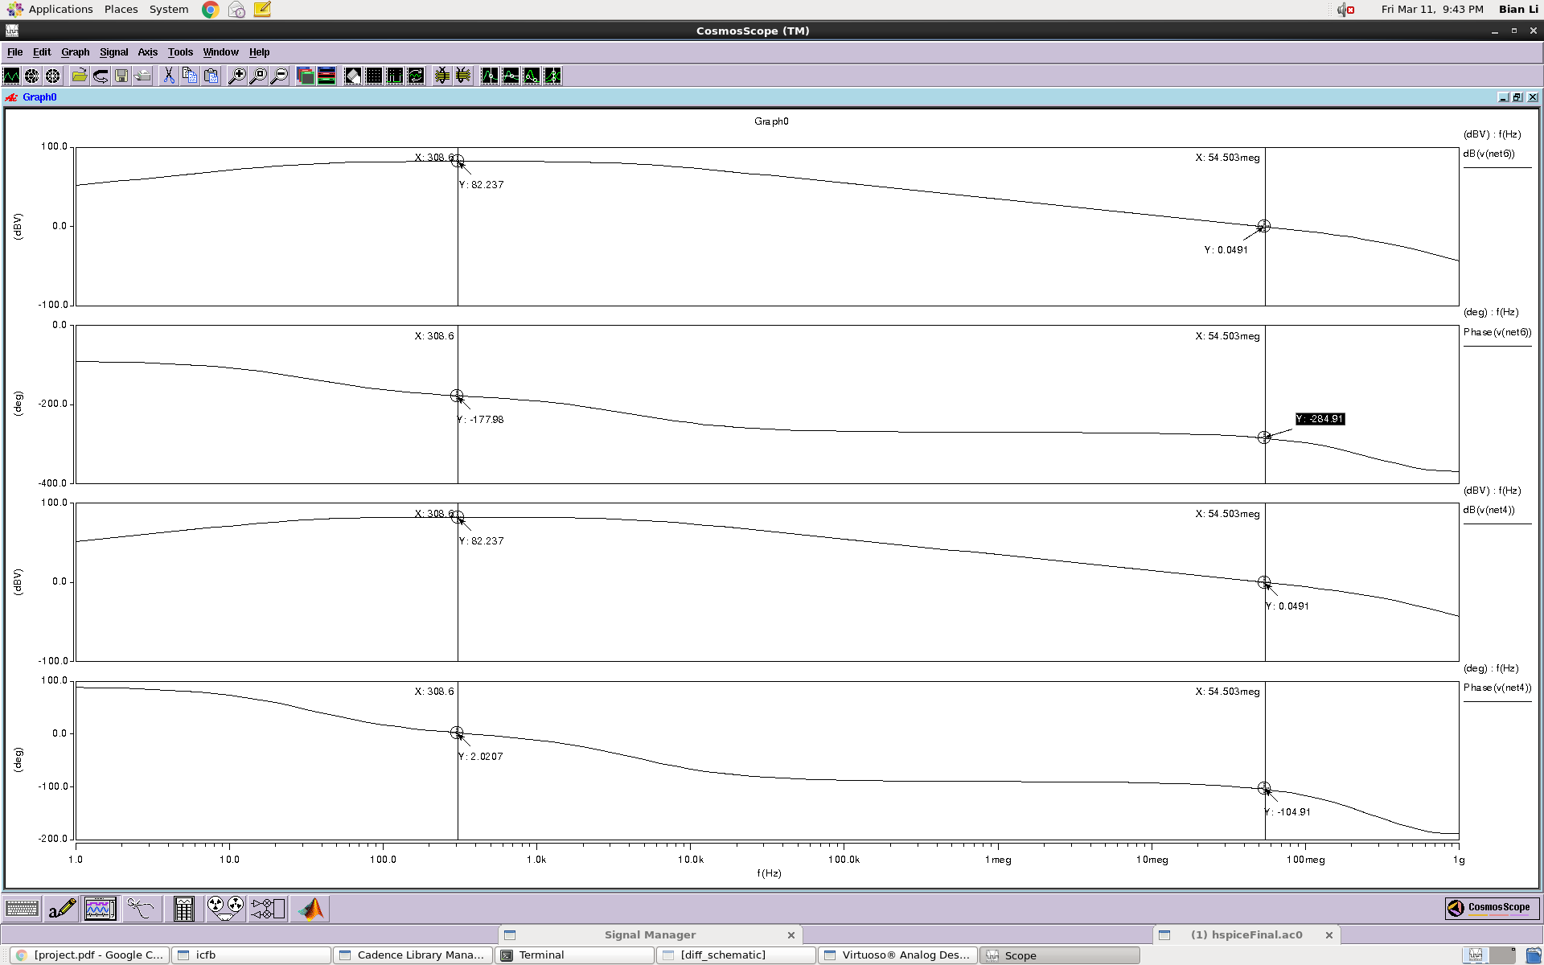

B.3 Fast case differential gain, UGBW and phase margin

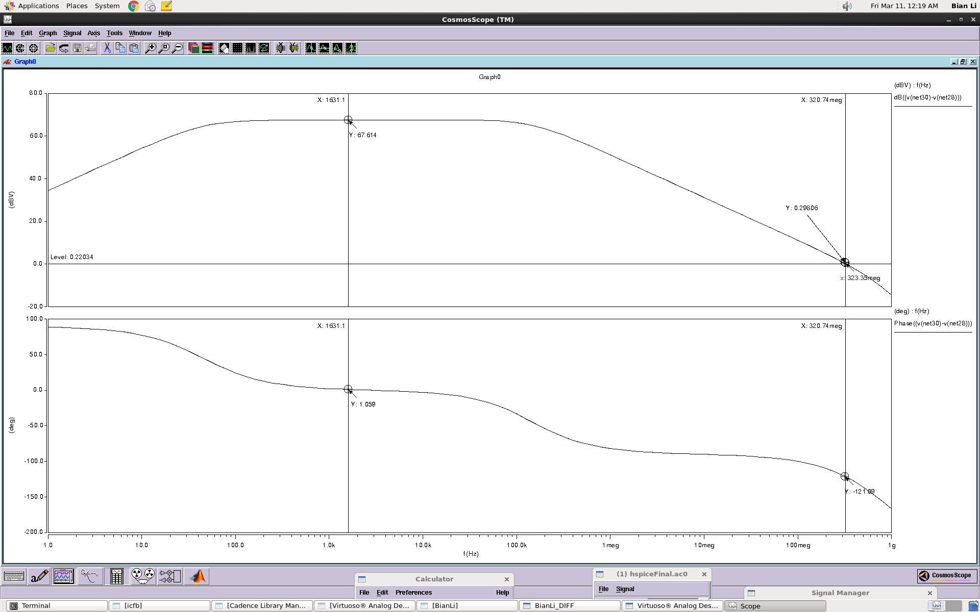

Fast case single ended gain, UGBW and phase margin

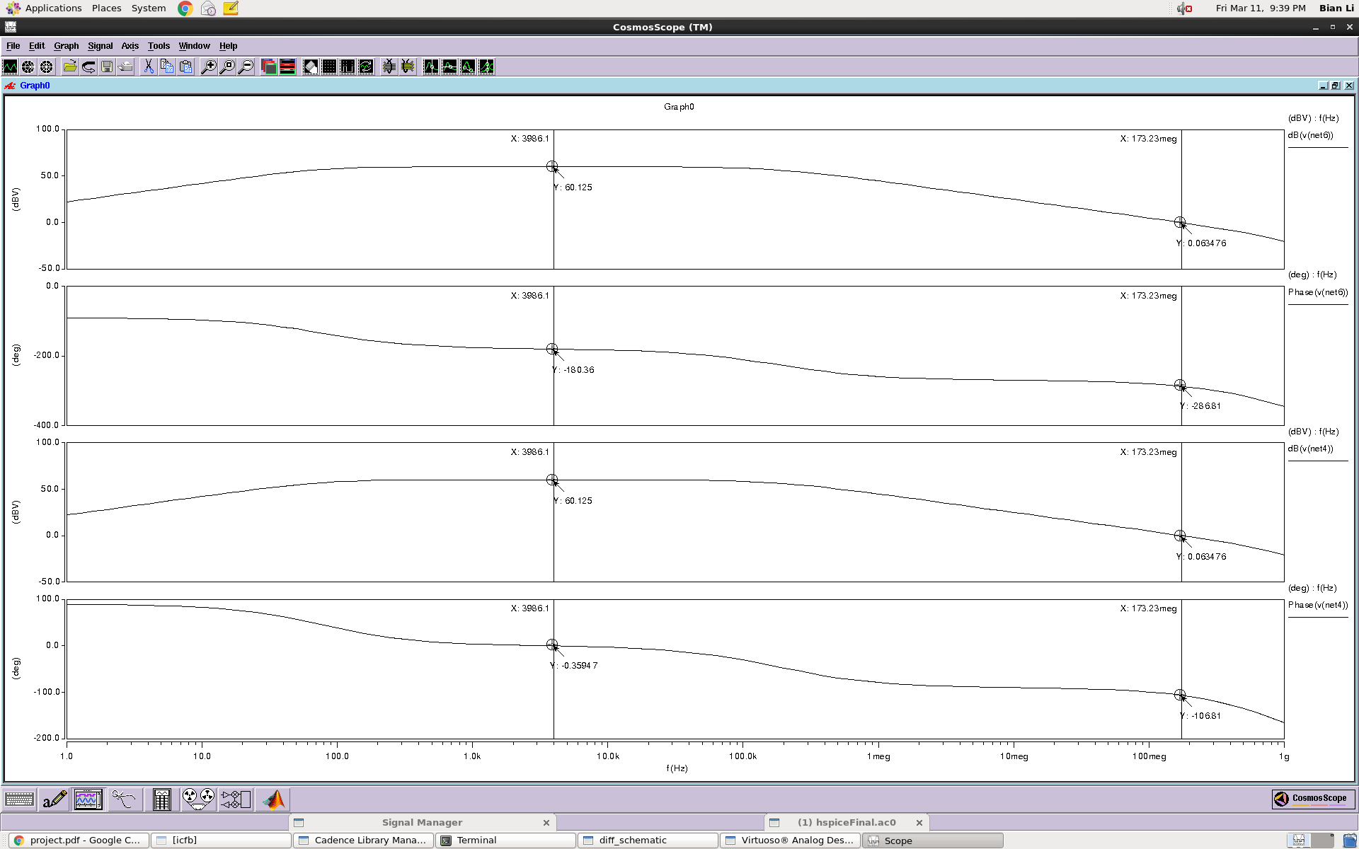

B.4 Typical case common mode gain and phase margin

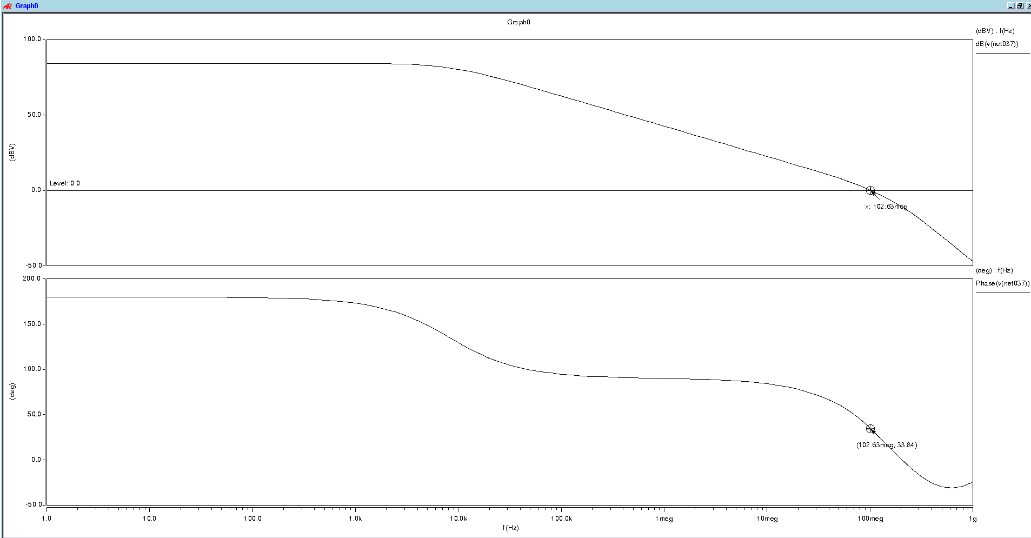

B.5 Slow case common mode gain and phase margin

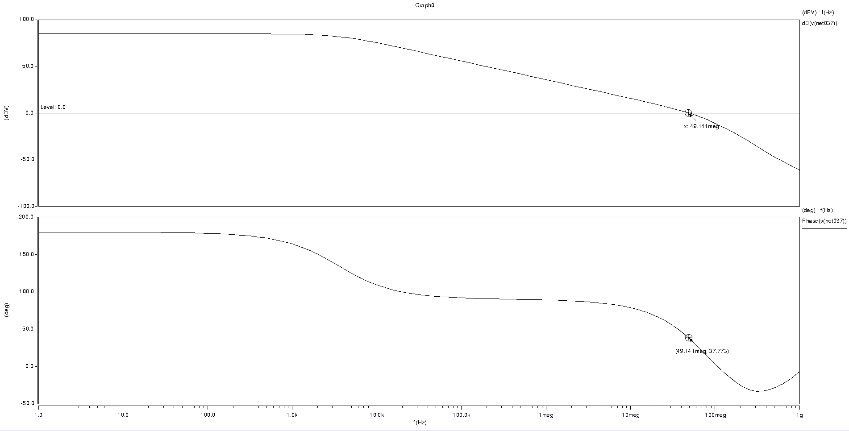

B.6 Fast case common mode gain and phase margin

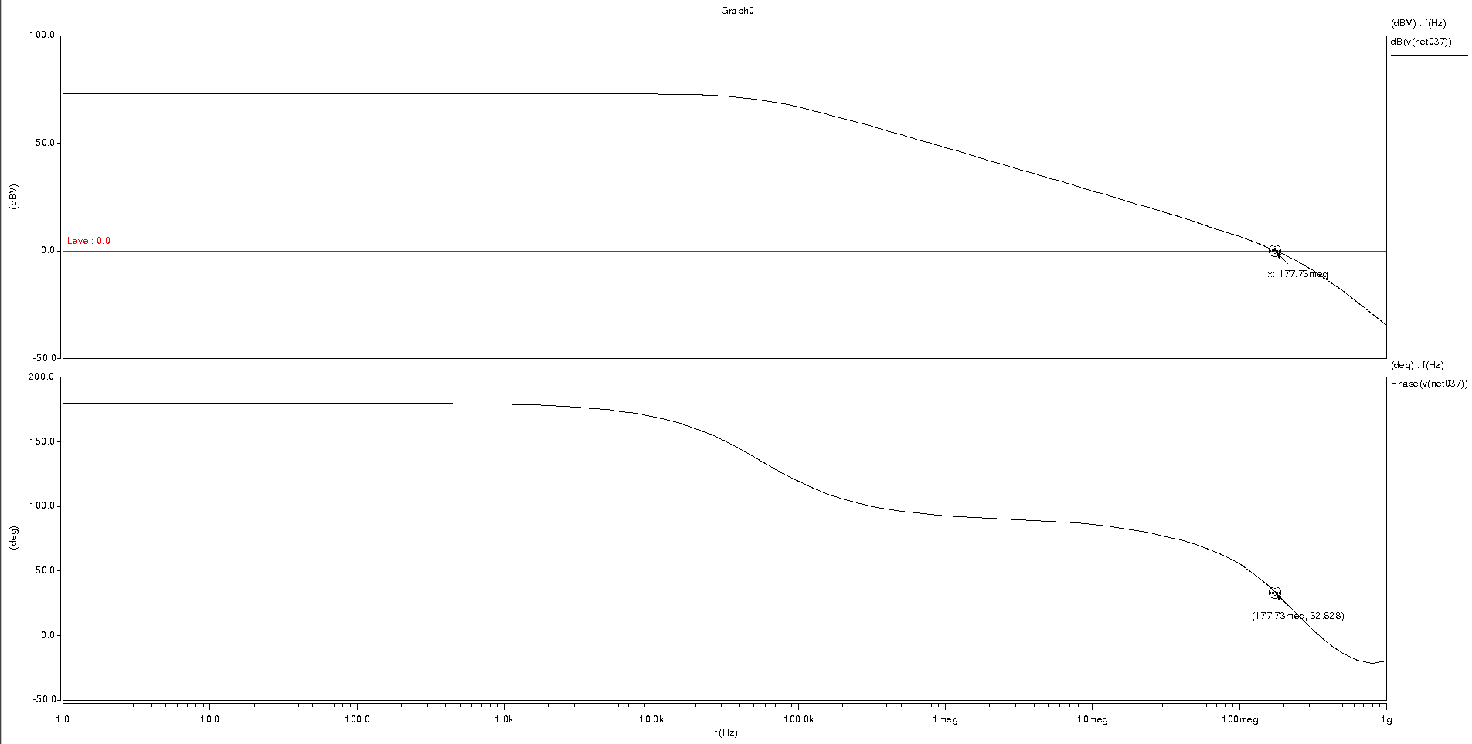

B.7 Typical case differential output swing

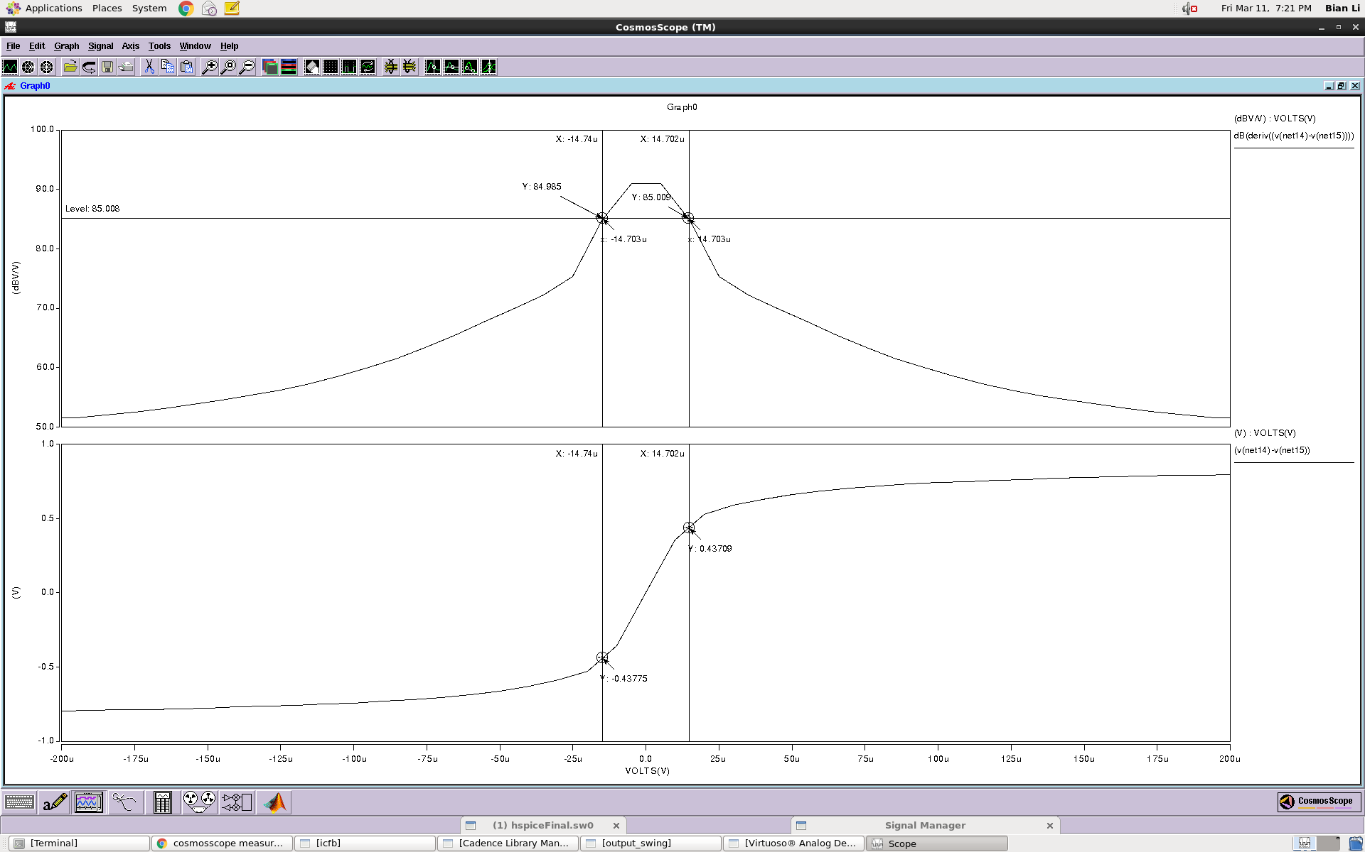

Typical case single ended output swing

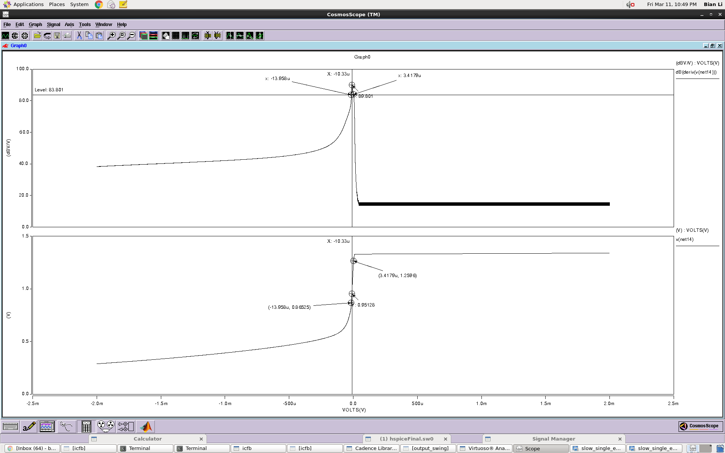

B.8 Slow case differential output swing  
 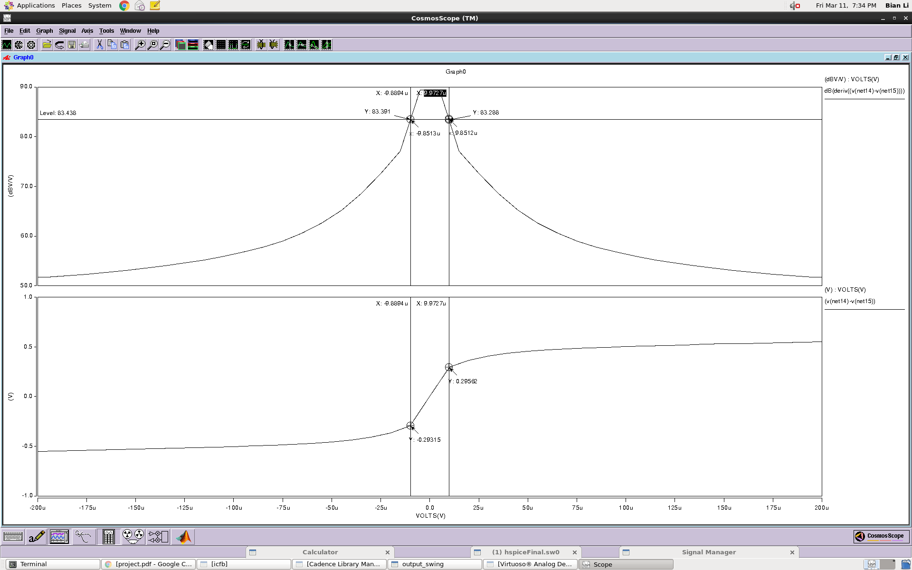

Slow case single ended output swing

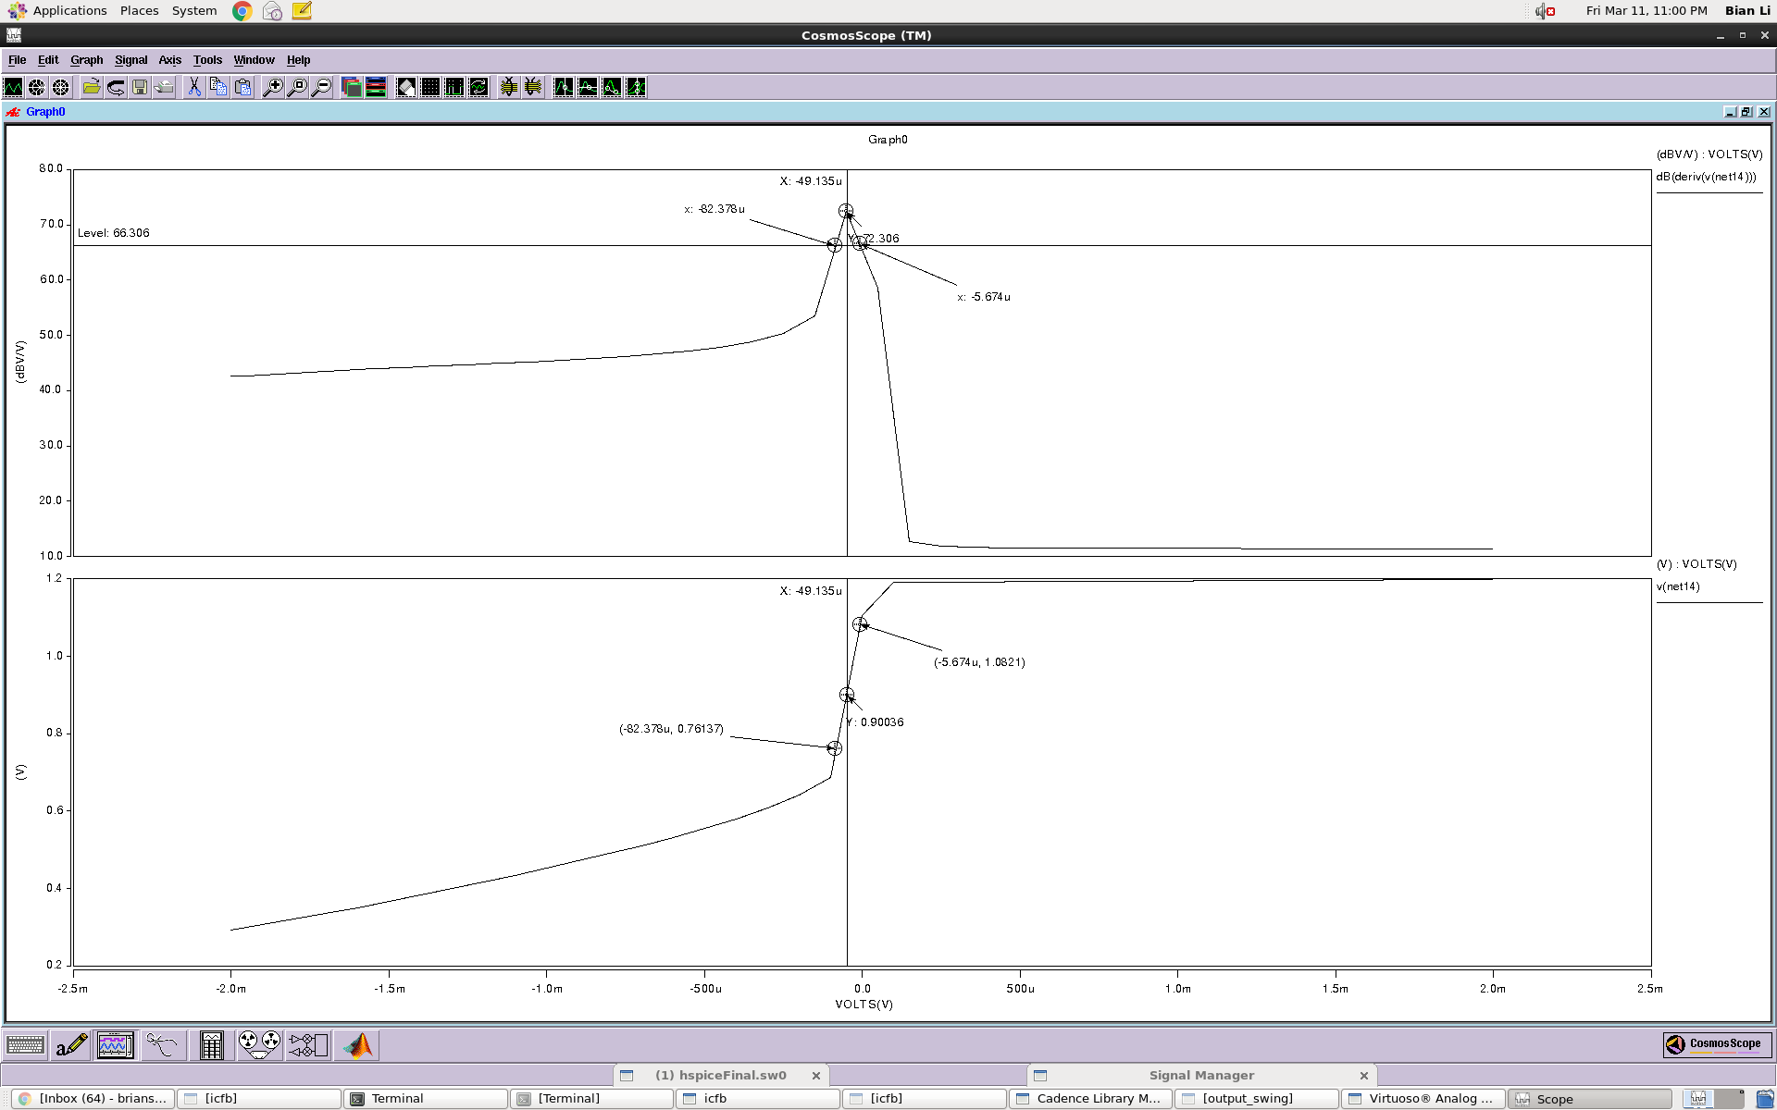

B.9 Fast case differential output swing

s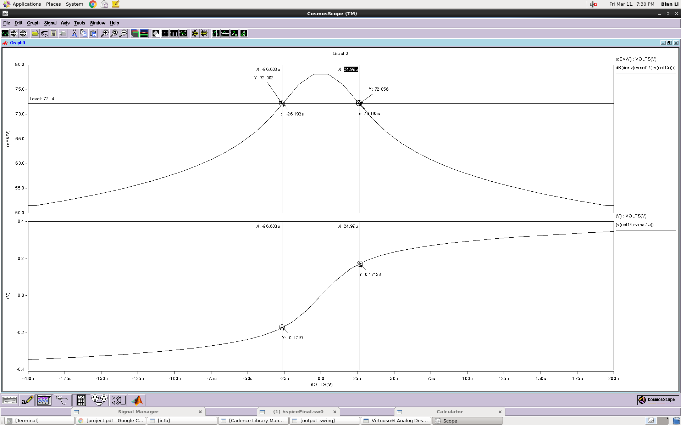

Fast case single ended output swing

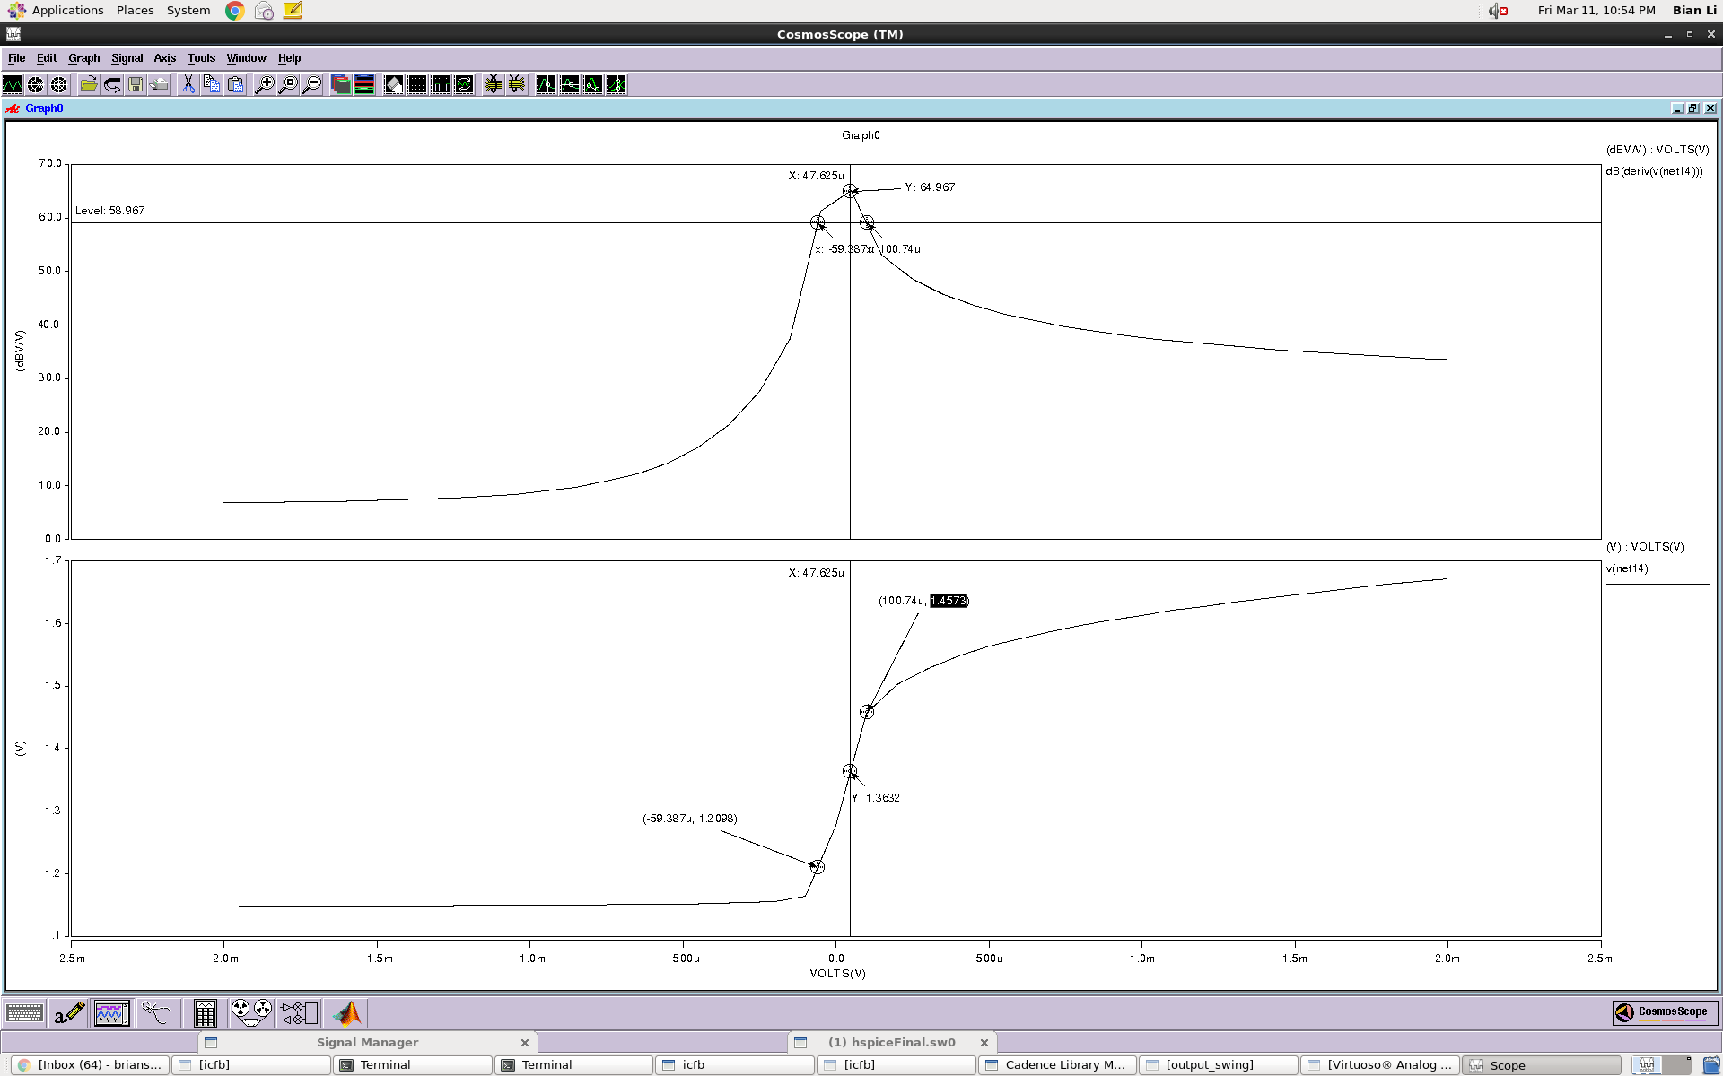

B.10 Typical Case Power Consumption

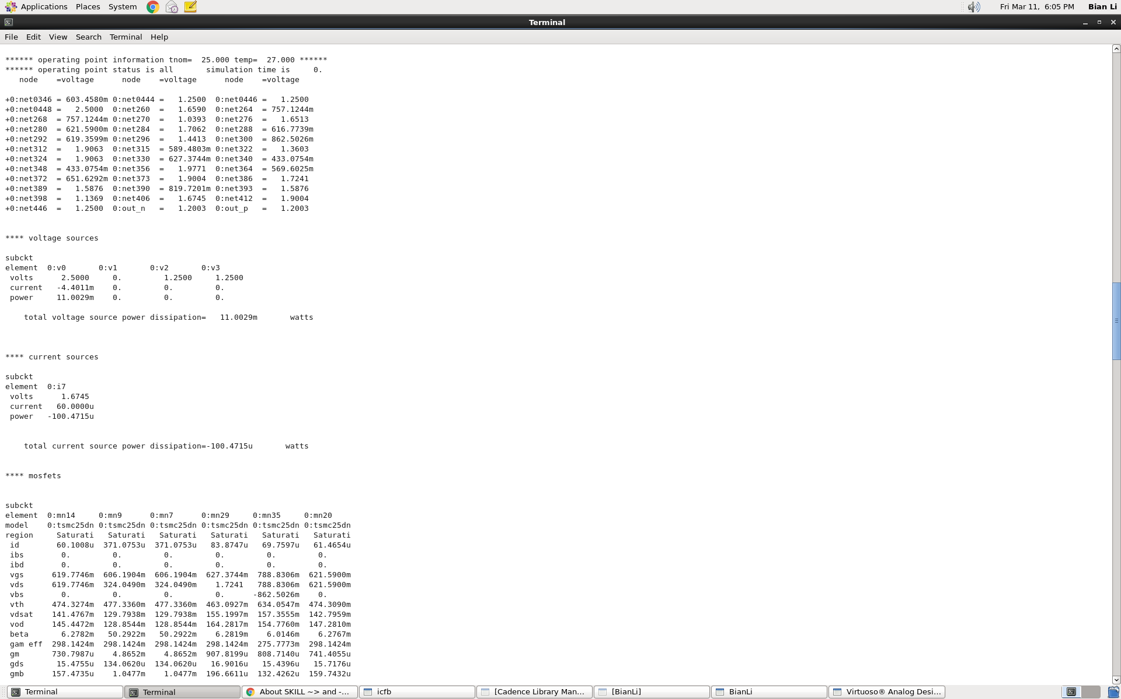

B.11 Slow case power consumption

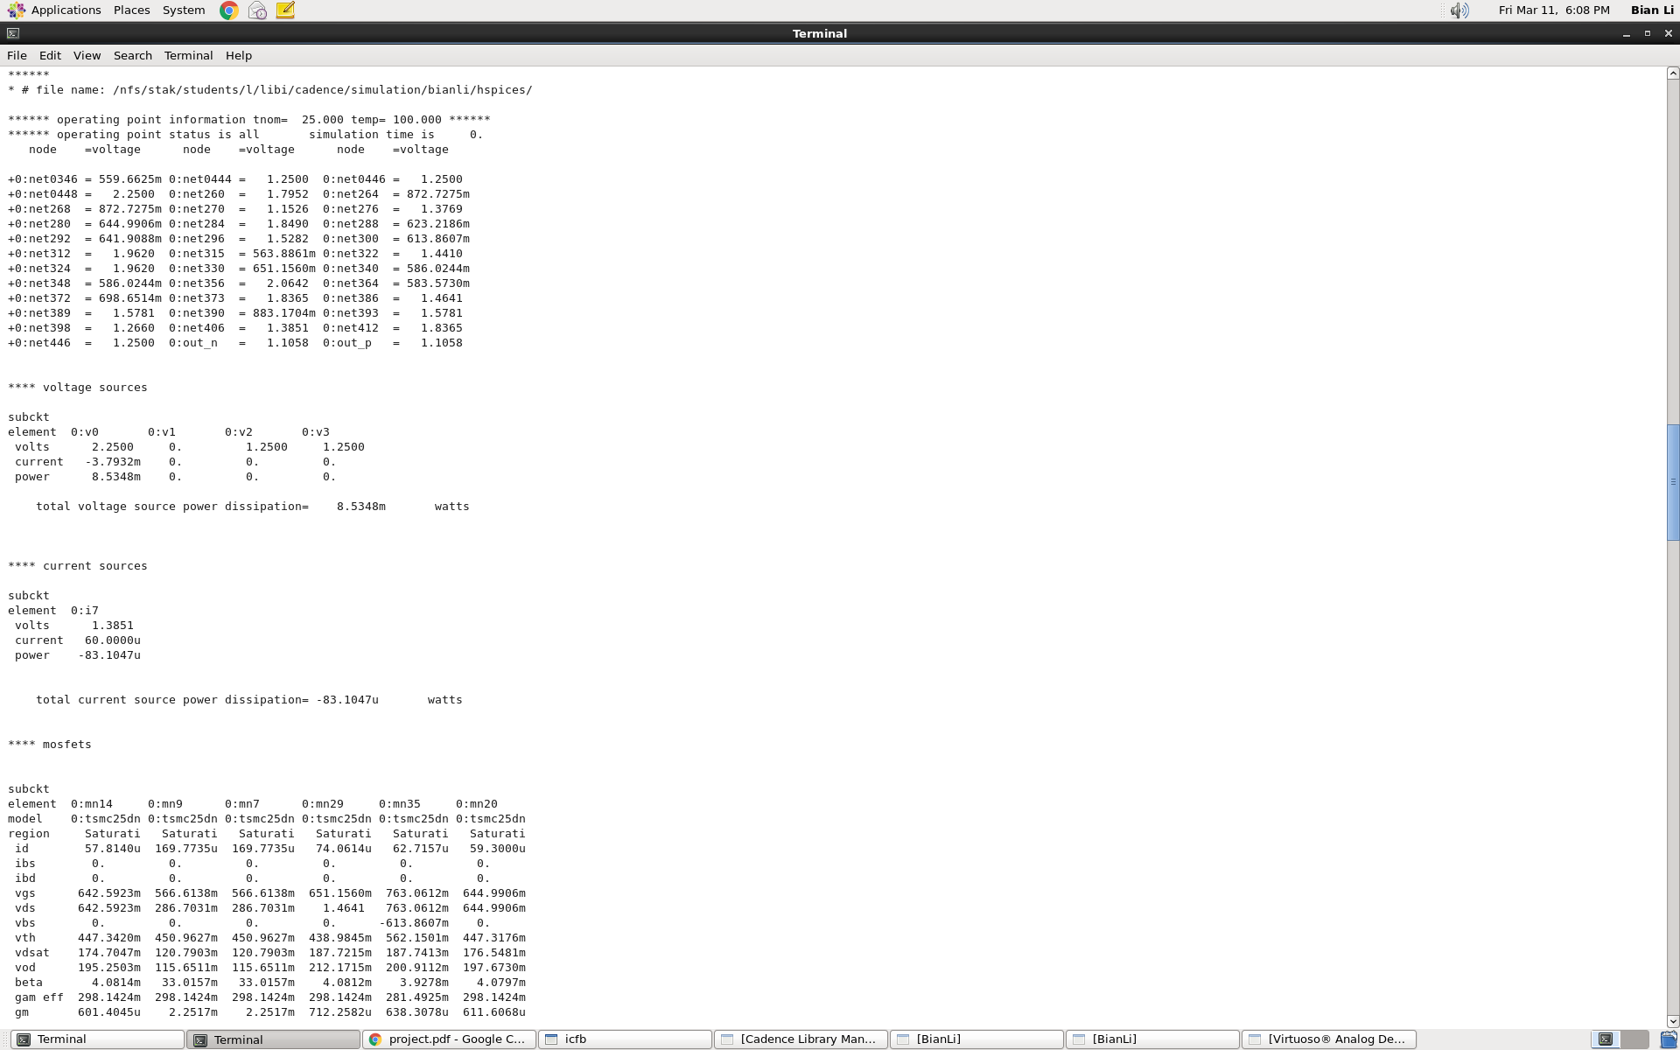

B.12 Fast case power consumption

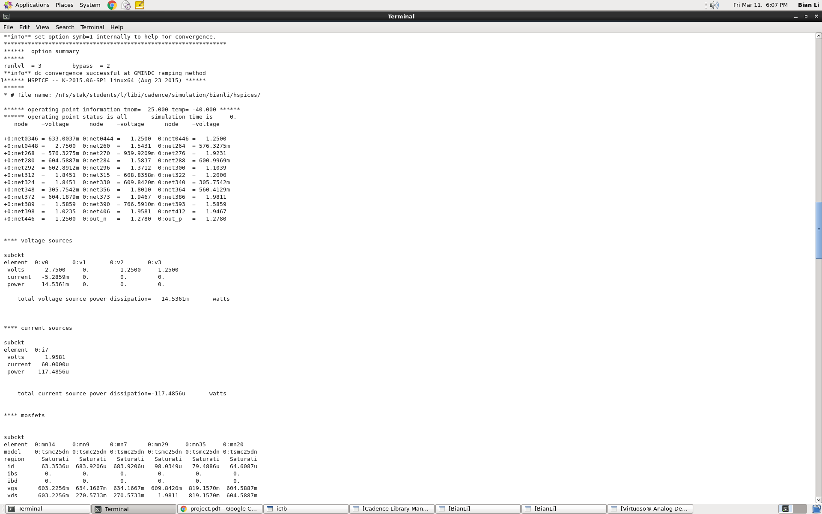

B.13 Typical common mode accuracy

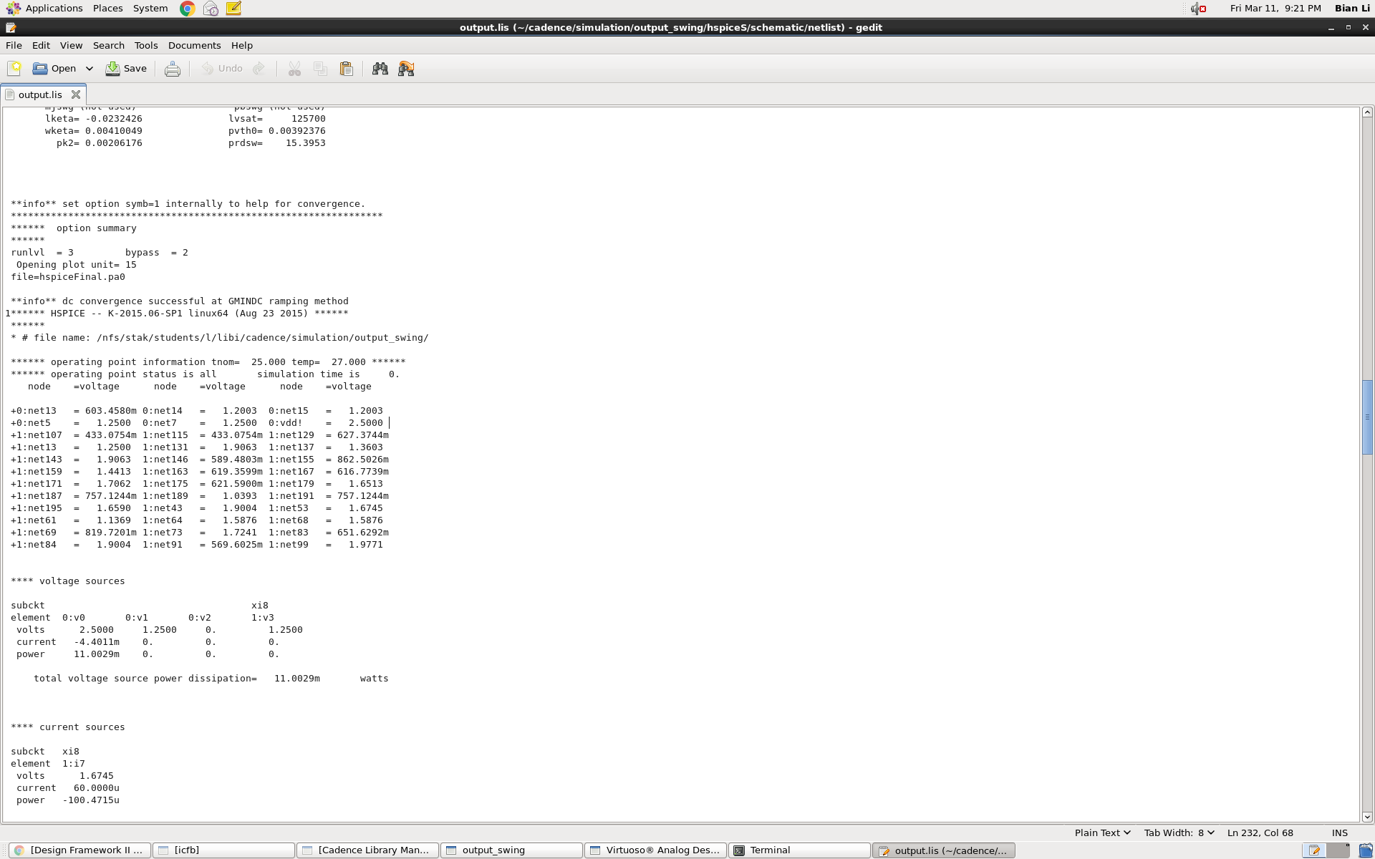

B.14 Slow common mode accuracy

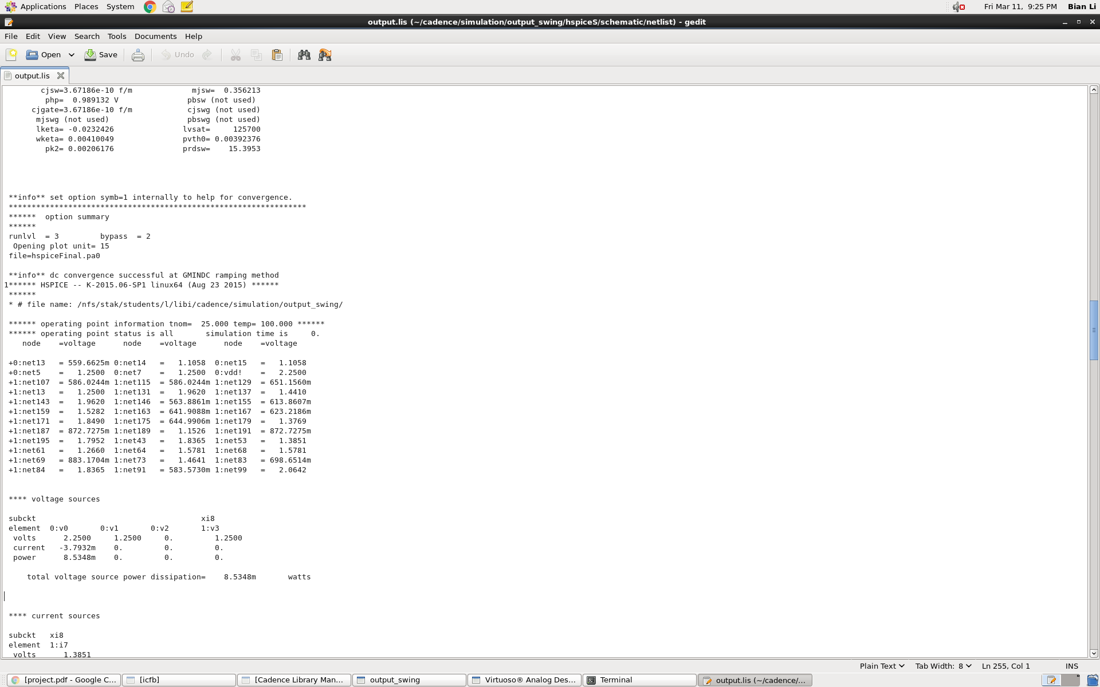

B.15 Fast common mode accuracy

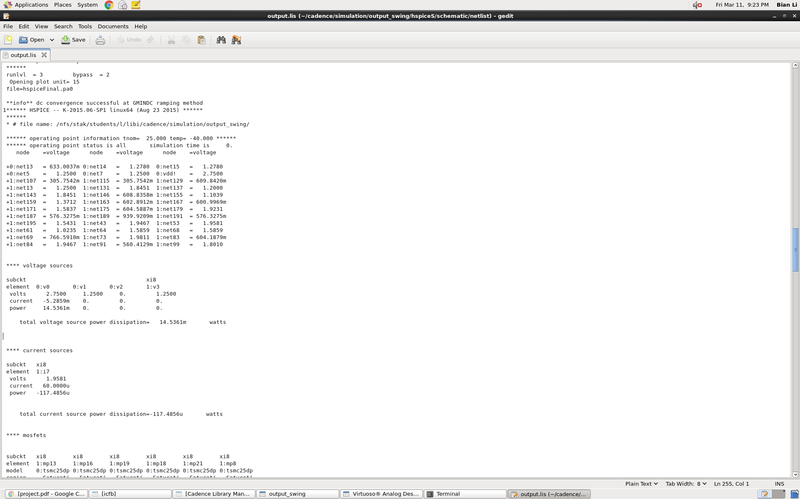

C.1 Layout screenshot

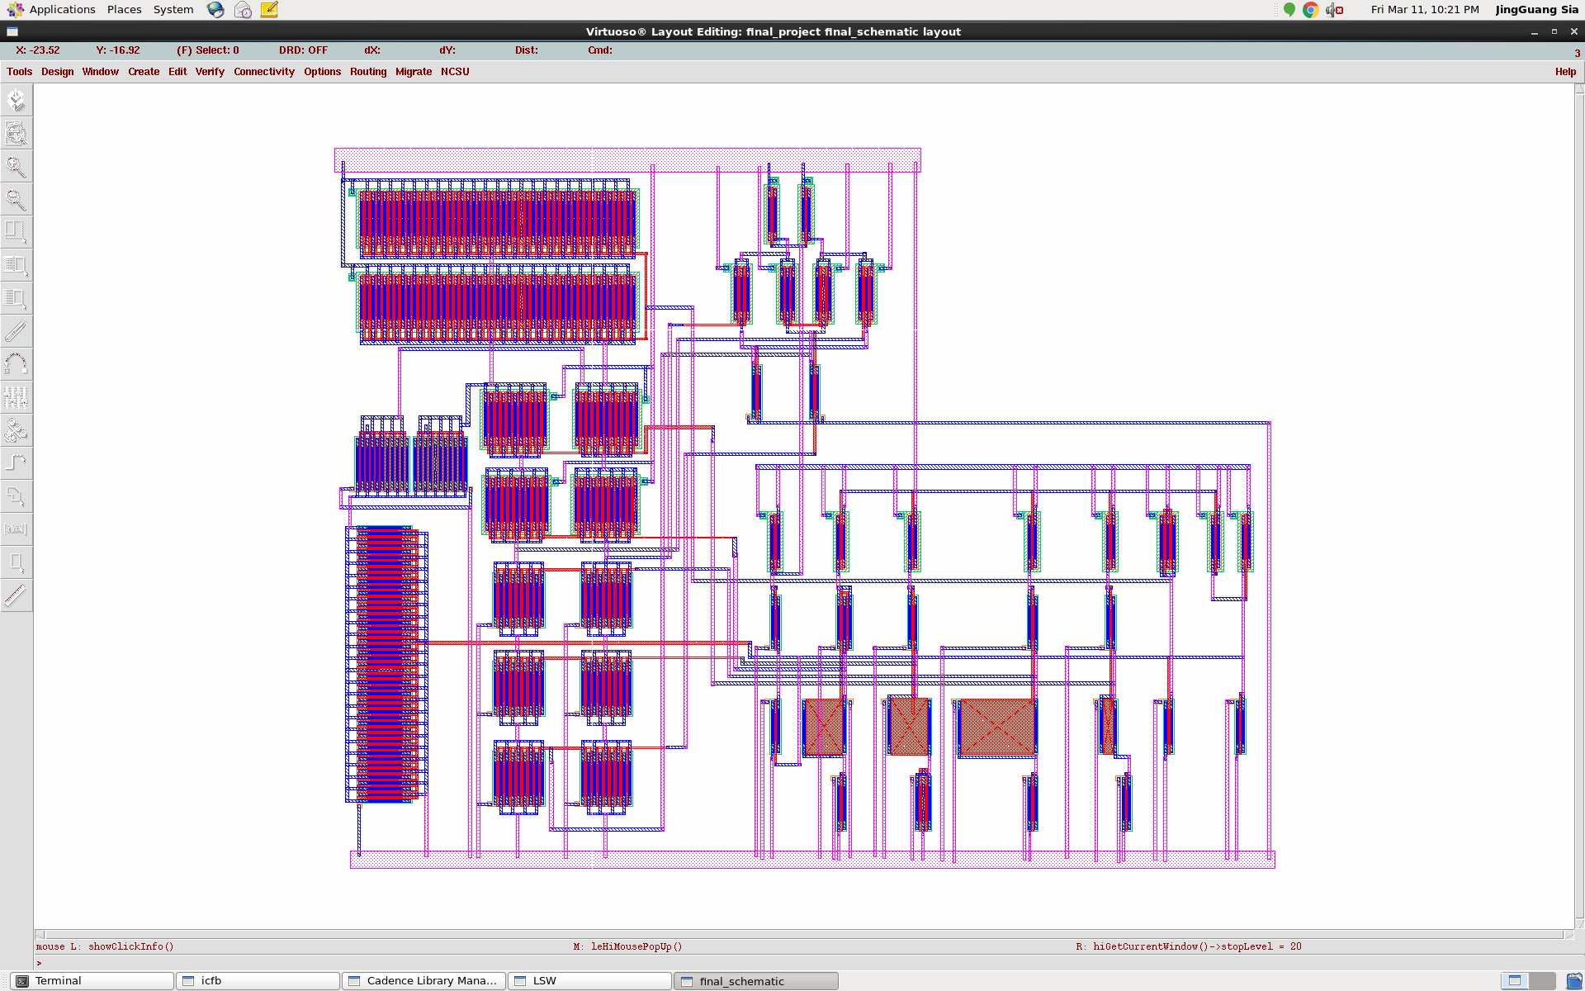

C.2 DRC screenshot